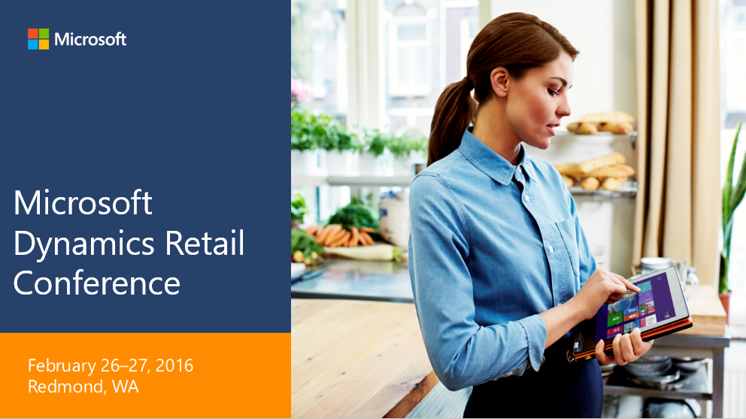

Microsoft Dynamics AX Retail

**Hands on lab - Self guided**

Creating new screen layouts

Disclaimer

The information contained in this document represents the current view of Microsoft Corporation on the issues discussed as of the date of publication. Because Microsoft must respond to changing market conditions, this document should not be interpreted to be a commitment on the part of Microsoft, and Microsoft cannot guarantee the accuracy of any information presented after the date of publication.

This lab manual is for informational purposes only. MICROSOFT MAKES NO WARRANTIES, EXPRESS, IMPLIED, OR STATUTORY, AS TO THE INFORMATION IN THIS DOCUMENT.

Complying with all applicable copyright laws is the responsibility of the user. Without limiting the rights under copyright, no part of this document may be reproduced, stored in, or introduced into a retrieval system, or transmitted in any form or by any means (electronic, mechanical, photocopying, recording, or otherwise), or for any purpose, without the express written permission of Microsoft Corporation. Microsoft may have patents, patent applications, trademarks, copyrights, or other intellectual property rights covering subject matter in this document. Except as expressly provided in any written license agreement from Microsoft, the furnishing of this document does not give you any license to these patents, trademarks, copyrights, or other intellectual property.

© 2016 Microsoft. All rights reserved. Microsoft, Microsoft Dynamics, and the Microsoft Dynamics logo are trademarks of the Microsoft group of companies.

Contents

Summary 3

Technology 3

Scenario overview 4

Prerequisites 4

Modern Retail POS (MPOS) 4

Exercise 1: 5

**Adding brand materials and image assets to the database** 5

Exercise 2: 7

**Define a visual profile** 7

Exercise 3: 8

**Define a button grid** 8

Exercise 4: 15

**Design a new screen layout** 15

Exercise 5: 21

**Assign visual profile to register** 21

Exercise 6: 23

**Assign layout to store workers, and publish all changes** 23

Exercise 7: 25

**Login using the worker account, and review layout** 25

# Summary

The objective of this lab is to <*provide Dynamics partners a guided view of Dynamics AX functionality in specific key areas. The intent of this lab is to Illustrate functionality within the Dynamics AX product with the view of helping you advance your knowledge in specific focus areas*>. This lab will focus specifically on the following business processes or tasks:

# Technology

New Dynamics AX

Cloud POS

Retail Modern POS

# Scenario overview

Fabrikam understands the power of their brand and the overall customer experience within their stores. For this reason, they ensure that each touch point with the customer is efficient, engaging, and communicates their brand. To accomplish this, Fabrikam can create shared profiles and layouts based on common image assets to provide a consistent customer experience.

Fabrikam employs various roles within a store. These individuals may have unique interface needs in addition to specific tasks they are expected to perform. Fabrikam can provide different layouts that target the specific user, and the scope of their work.

# Prerequisites

This document assumes the reader is setting up a new screen layout for the **Cloud POS** (CPOS) client.

Before attempting this HOL, you should already activate and sign into a **Cloud POS** application to familiarize yourself with the content we will be changing. This document does not cover the steps related to first time activation and initial device/application setup.

# Modern Retail POS (MPOS)

The same steps can be used to create/update screen layouts for MPOS as well. The difference being, everywhere a reference is made to “**Application type**”, this would need to be set to “**Modern POS for Windows**”.

This means the Application type for the **Visual profile**, the **Screen layout**, and the **Device** using the application all need to be set to “**Modern POS for Windows”**. The application type must be consistent across these to function properly.

For example:

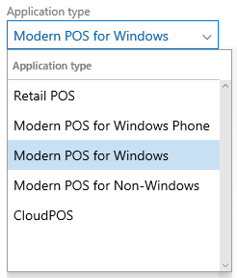

# Exercise 1:

## **Adding brand materials and image assets to the database**

|  |  |
| --- | --- |
| **TASK** | **Detailed steps** |
| 1.1 | In AX go to **Retail and commerce > Channel setup > POS setup > POS > Images** |
| 1.2 | Click **New** and enter Image ID: **9000**, and click **Browse** |
| 1.3 | Browse to the image that you want to use for the POS login image, and select it. |
| 1.4 | Click **New** and enter Image ID: **9001**. Click **Browse**.Select the image that you want to use for the Welcome Screen image on POS. |

# Exercise 2:

## **Define a visual profile**

|  |  |
| --- | --- |
| **TASK** | **Detailed steps** |
| 2.1 | Go to **Retail and commerce > Channel setup > POS setup > POS profiles > Visual profiles**. |
| 2.2 | Provide the following information for your new profile:   * Profile number: **HOL1** * Description: **HOL Visual Profile** * Application type: **CloudPOS** * Theme: **Dark** * Accent color: **Blue** * Login background > Landscape image ID: **9000** * Login background > Portrait image ID: **0** |

# Exercise 3:

## **Define a button grid**

|  |  |
| --- | --- |
| **TASK** | **Detailed steps** |
| 3.1 | Go to **Retail and commerce > Channel setup > POS setup > POS > Button grids**. |
| 3.2 | Click **New** and provide the following details   * Button grid ID: **HOL1** * Name: **HOL Tasks** |
| 3.3 | Click **Designer**  If prompted, choose **Run**.    Wait for the designer to finish downloading, and launch. |
|  | **NOTE:**  Each initial 1x1 button cell in the designer is represented in MPOS as a 1:1 button.  To create larger buttons, these cells must be expanded into 2:1, 2:2, or 4:2 sizes.  To create button grids that will include larger buttons, these rows and columns should be accounted for upfront when designing a new button grid layout.  Our target layout will follow the structure shown below. On the left is the final shape and size of the buttons, and on the right is the underlying column and grid sizes that were used. |
| 3.4 | Expand the designer window so all actions are visible, and click **New design**. |
| 3.5 | Create a new layout with **4 columns** and **6 rows**.    Which should give you this. |
| 3.6 | To create larger buttons, the adjacent ones will need to be deleted to create space. Once deleted, the remaining buttons can be updated to take up additional unused column and row space.  To create a 2:1 button, first right-click the button adjacent to the one that you want to increase, and click **Delete button** to clear space on the right side.    Right-click the targeted button, click **Button properties.** Use the **Appearance panel** to update **Size in columns** to **2**. Click **OK**. |
|  | That should leave you with a 2:1 button. |
| 3.7 | Using the same technique described above, delete buttons to clear space, and size the buttons to match the following dimensions. |
| 3.8 | Right-click the buttons and select **Button properties** to update the buttons to the following specifications. |
| 3.9 | Verify the button grid looks like the example below, and close the form by clicking the **Close** button in the upper-right. |

# Exercise 4:

## **Design a new screen layout**

|  |  |
| --- | --- |
| **TASK** | **Detailed steps** |
| 4.1 | Go to **Retail and commerce > Channel setup > POS setup > POS > Screen layouts**.  Click **New** and specify the following:   * Screen layout ID: **HOL1** * Name: **HOL1** * Application type: **CloudPOS** * Height: **768** * Width: **1366**   Click **Save**. |
| 4.2 | In the button grids section, click **Add** and include the following zones and button grids:   * Welcome screen 1 : FABMPOSW1, Getting started * Transaction screen 1 : HOL1, HOL Tasks * Transaction screen 2 : FABMPOST5S, Payment methods |
| 4.3 | Expand the Images section, click **Add**, and include the following zone and image:   * Welcome screen 1, 9001 |
| 4.4 | Click **Designer** in the Action Pane.    When the form opens, increase the zoom size to **100%**,as shown below.    If there are issues opening the designer, see the troubleshooting section below for help. |
| 4.5 | Drag components onto the canvas from the list on the left. The components can be resized and should snap to the grid shown on the screen.    Add the following components to the screen. Components can be customized to render different content by right clicking, and selecting **Customize**.    **Tab control**   * Tab1   + Label: Actions   + Contents: Button grid 1 * Tab2   + Label: Customer   + Contents: Customer card (Customize the contents)   **Receipt pane** (customize with the columns provided)   * Lines   + Product name, Quantity, Total (without tax) * Payments   + Payment method, Currency, Amount * Delivery   + Product name, Delivery method, Status   **Totals panel** (customize the right column)   * Subtotal, Tax, Payment   **Number pad**  **Button grid 2** |
| 4.6 | Verify the position and contents of the components and close the form.  Example:    Make sure you click **Save** when prompted. |

# Exercise 5:

## **Assign visual profile to register**

|  |  |
| --- | --- |
| **TASK** | **Detailed steps** |
| 5.1 | First, identify the register you are currently using. This can be found a number of ways.  From within CPOS or MPOS, go to the settings page:      From AX, if you know your device you can find the register here  Go to **Retail and commerce > Channel setup > POS setup > Devices** |
| 5.2 | In AX, go to **Retail and commerce > Channel setup > POS setup > Registers**  Locate your register and click **Edit.** |
| 5.3 | Update the **Visual profile** to use the one you created, **HOL1**    Click **Save**. |

# Exercise 6:

## **Assign layout to store workers, and publish all changes**

|  |  |
| --- | --- |
| **TASK** | **Detailed steps** |
| 6.1 | Go to **Retail and commerce > Employees > All workers**. |
| 6.2 | Find worker **000137, Emma Harris**. Open the record, and click **Edit**. Choose the **RETAIL** content tab. |
| 6.3 | Add the **HOL1** screen layout that you created earlier to the Screen layouts list. |
| 6.4 | The new layouts, profiles, and worker details must be replicated to the channels.  Go to **Retail and commerce > Retail IT > Distribution schedule**.  Select job **1060, Staff** and click **Run now**.  Select job **1070, Channel configuration** and click **Run now**.  Select job **1090, Registers** and click **Run now**. |
| 6.5 | Give the jobs time to finish, and then return to your MPOS client. This may take a few minutes for all changes to be applied to the database.  You can also view the status of a given job by clicking **History** to verify that it has been applied. |

# Exercise 7:

## **Login using the worker account, and review layout**

|  |  |
| --- | --- |
| **TASK** | **Detailed steps** |
| 7.1 | Open your CPOS client. If you have not yet logged off, do so now. |
| 7.2 | From the start screen, log in with Emma Harris.  Operator ID: **000137**  Password: **123** |
| 7.3 | Verify that the welcome screen and transaction screen have the updated content.  Welcome screen    Transaction screen |

**TROUBLESHOOTING**

1.0 If the designers do not open

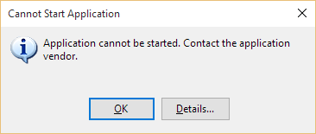

**When using Edge with Windows 10**

1. Open Edge
2. Open Settings.

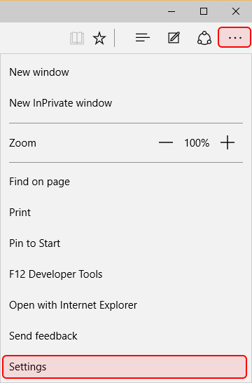

1. Click **Choose what to clear** under Clear browsing data.

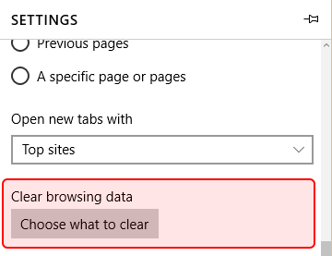

1. Make sure everything is selected, as shown below.

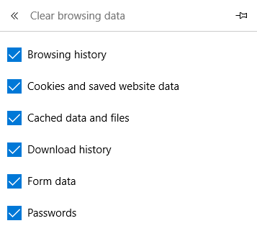

1. Click **Clear**.
2. Close the browser.
3. Open a Command Prompt as an Administrator

Type: “**rundll32 dfshim CleanOnlineAppCache**”, press Enter.

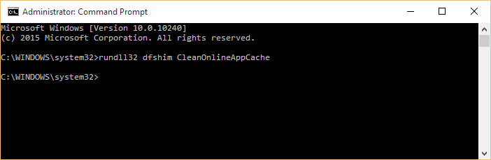

1. Open a new Edge browser window, and log back into AX.

**When using Internet Explorer**

1. Open Internet Explorer.
2. Open **Tools > Internet options**.

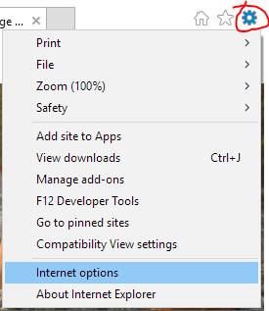

1. Click **Delete**.

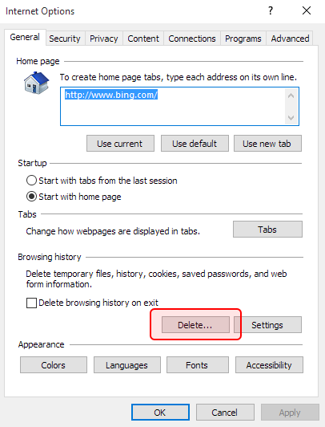

1. Make sure the following settings are in place, and then click **Delete**.

**Preserve Favorites website data** is selected.

**Passwords** is selected.

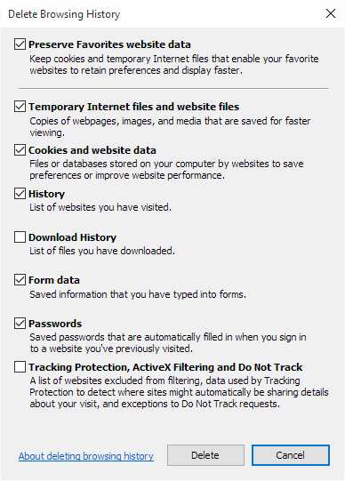

1. Close the browser.
2. Open a Command Prompt as an Administrator.

Type: “**rundll32 dfshim CleanOnlineAppCache**”, press Enter.



1. Open a new Internet Explorer browser window, and log back into AX.